# **IP Restrictions Setup**

IP Restriction is a tool that is provided within the affiliate portal to ensure that an affiliate’s account cannot be accessed outside of the desired IP address(es) or IP ranges. It allows you to “White-List” a group of IPs your administration team or applications may communicate from, providing you the ability to add any IP you wish to grant access to (either the control panel or a website).

## **Setup/Functionality Instructions**

To set up an IP Restriction on your affiliate account, you will first need to log in and click on Options.

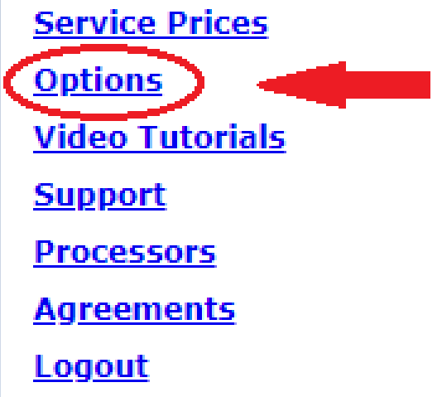

Once you are in settings, under the heading “General Options”, click on “IP Restrictions.”

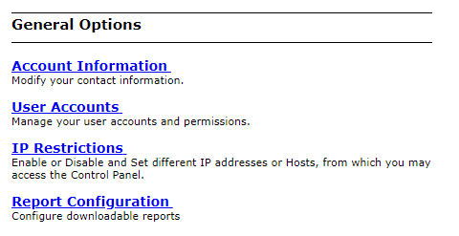

Next, you will want to take the IP address and/or range used to access your account and enter this into the text box under the “IP/Host” column. For those who are unaware of their current public IP address, you will notice that the IP address will be shown on the top. If you click on the “Add (IP Address)” link, it will populate the current IP Address into the list of IP Restrictions under “IP/Hosts”.

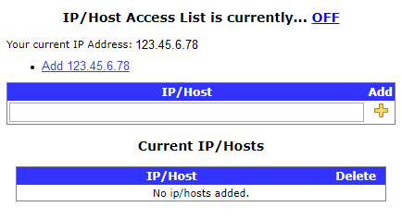

When you have completed entering the IP address/range, click on the yellow '+' under the add column to add the IP. This will now display the IP address/range added under the “Current IP/Hosts” table.

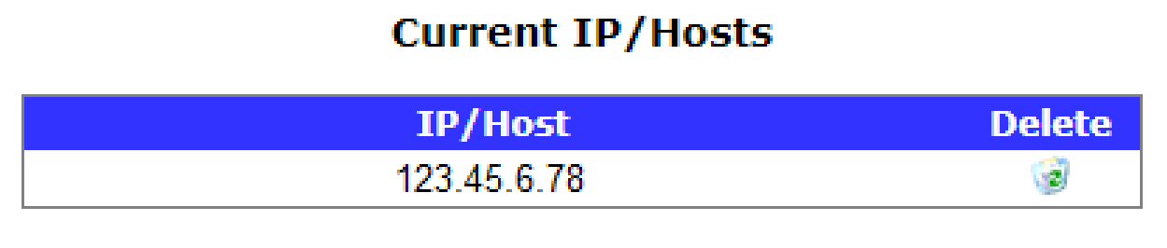

Once the appropriate IPs/Hosts have been added, click the ‘OFF’ hyperlink text next to “IP/Host Access List is currently…” to toggle the service ‘ON’.

|  |  |
| --- | --- |
| **Disabled** | **Enabled** |

### **Notes**

Restrictions can be activated when at least one IP address has been added for the method of connection.

After IP Restrictions have been enabled, any attempt to log in or send transactions from a server or IP that has not been white-listed will produce an 'Authentication Failed' message regardless of the accuracy of the credentials.

You may add as many IP addresses/ranges as desired.